CEN 4010 Fall 2021

Final Project Portfolio

**Peace of Mind**

Team Number: Group 03

**Team Members and Roles:**

**Product Owner and Scrum Master/GitHub Master:**

Ryan Milrad - [rmilrad2016@fau.edu](mailto:rmilrad2016@fau.edu)

**Lead Frontend:**

Juan Pablo Idrovo - [jidrovo2019@fau.edu](mailto:jidrovo2019@fau.edu)

**Lead Backend:**

Mauricio Retana Rodriguez - [mretanarodri2018@fau.edu](mailto:mretanarodri2018@fau.edu)

**Frontend Support:** Armaghan Ali - [alia2019@fau.edu](mailto:alia2019@fau.edu), Ryan Bharath - [rbharath2018@fau.edu](mailto:rbharath2018@fau.edu), Joseph Brown - [josephbrown2020@fau.edu](mailto:josephbrown2020@fau.edu)

**Backend Support:** Ryan Milrad, Ryan Bharath

November 25, 2021

**Project URL:** <https://peaceofmind-cen4010.xyz/>

**Revision History**

| Change # | Date changed | Summary |
| --- | --- | --- |
| 00 | 09-25-2021 | Creation of the document |
| 01 | 10-20-2021 | High Level Functional Requirements - Removed Entertainment Ratings  Data Definition - Removed Entertainment features |
| 02 | 10-21-2021 | High Level Functional Requirements - Added more to the Administrator section, made changes to the Browse Website section.  Added Like/dislike functionality.  Added Search Bar that allows user to look for blog posts.  Non Functional Requirements - Minor change to the performance attribute |

# 1 Product Summary

Peace of Mind is a blog site that allows users to view blog posts and connect with other users. During these hard times, it is difficult to meet up with friends and family in person. To make our users feel at home, we designed a website that does just that. People from all over the world will have access to using our website. You can create an account to view the posts and comment on them.

To market the product, we will pick from a few people to have exclusive access to our website and give us valuable feedback to make it better. We can also have an advertisement to expose more potential customers to our product and have them share with their friends and family.

### 1.1 Name of Product

Peace of Mind

### 1.2 Explicit list of ALL Major Committed Functions (Priority 1)

1. Account Creation
   1. The user can create an account to be a member of the website so that they can take advantage of the features that the website has.
2. About Us Page
   1. The user can navigate to this page to view the members who created the website.
3. Edit Profile
   1. The user can edit their profile where they can change their profile picture, name, contact information and biography.
4. Profile Page
   1. The user can now see their own and other peoples’ post and comments on Peace of Mind by going into their profile page. The user is also able to access those posts by clicking on the URL link.
5. Covid Info Page
   1. The user can access the covid information page where they can read up on information about Covid-19. They are also able to view the amount of cases and deaths so far (In the United States).
6. Website Browsing
   1. The user can navigate to several pages on the website (About Us. Covid Information, Blog categories, Blog Post, Edit Profile pages).
   2. If the user enters the blog posts section, he/she can navigate that page using the search bar which allows the user to look for posts by post title, summary, author, or category.
7. Comments
   1. The user can view the blog post and make a comment on it.The comment is viewable by other users.
8. Blog Page
   1. The user can navigate through the blog page where they can see what blogs has been posted and what blogs they can view.
9. Administrative Rights
   1. The administrator is allowed to create new blog categories and new blog posts. They can also grant other users administrative rights.
   2. The administrator can create new blog categories to keep blog posts more organized
   3. The administrator can edit blog posts and edit blog categories
   4. The administrator can delete the user’s account upon request
10. Maintenance of the Website
    1. The development team (group 3) will be in charge of maintaining the Peace of Mind website.
    2. Blog posts and blog categories can be maintained through the administrator dashboard.
11. Category Page
    1. The user can view the category page and look at what they want to view. For example, if the user is interested in sports, they can take a look at the sports category
12. Like/Dislike Post
    1. Registered users can click the like or dislike button, and the number of persons that liked or disliked the same post will be displayed.

### 1.3 Product URL

<https://www.peaceofmind-cen4010.xyz/>

# 2 Milestone Documents

2.1 Modified Milestone 3 Document Link: [Milestone 3: More Detailed Requirements, Architecture and a Vertical Software Prototype](https://docs.google.com/document/d/196Cn9Fye2sZiQFiSloxkJtW2CJRco50FLZedT8qO11A/edit?usp=sharing)

2.2 Instructors feedback summary: Instructor did not give feedback.

# 3 Screenshots of actual final product as shown in the demo

Account Creation

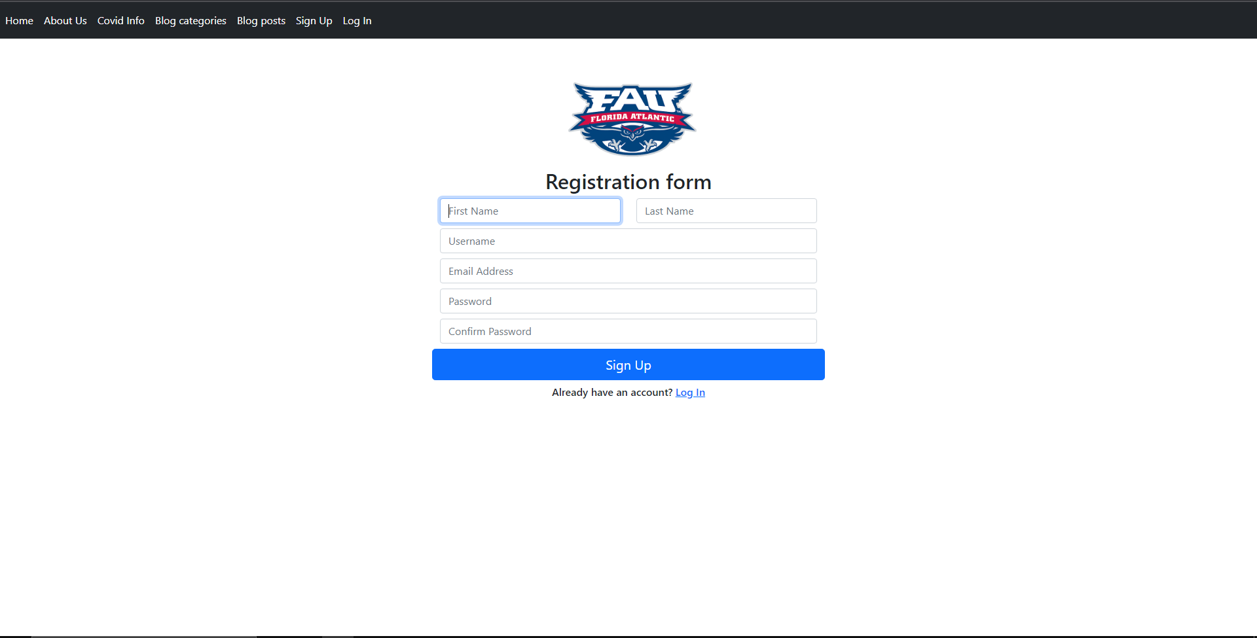

About Us Page

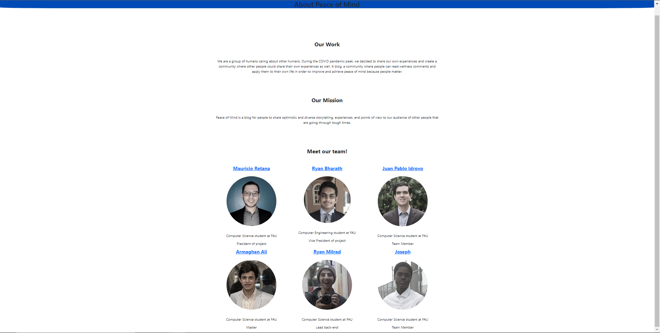

Edit Profile

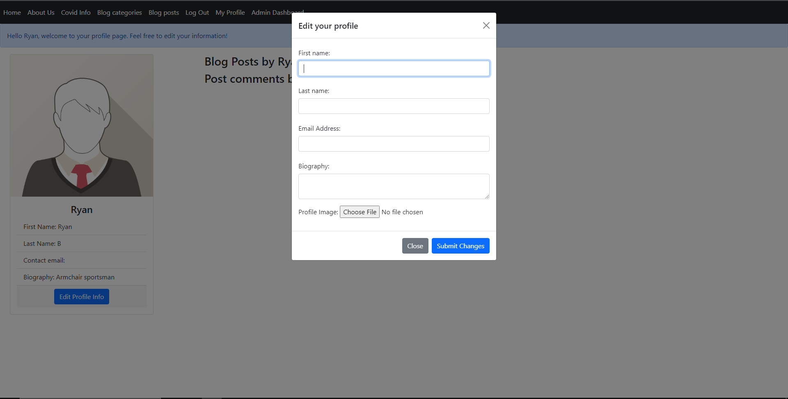

Profile Page

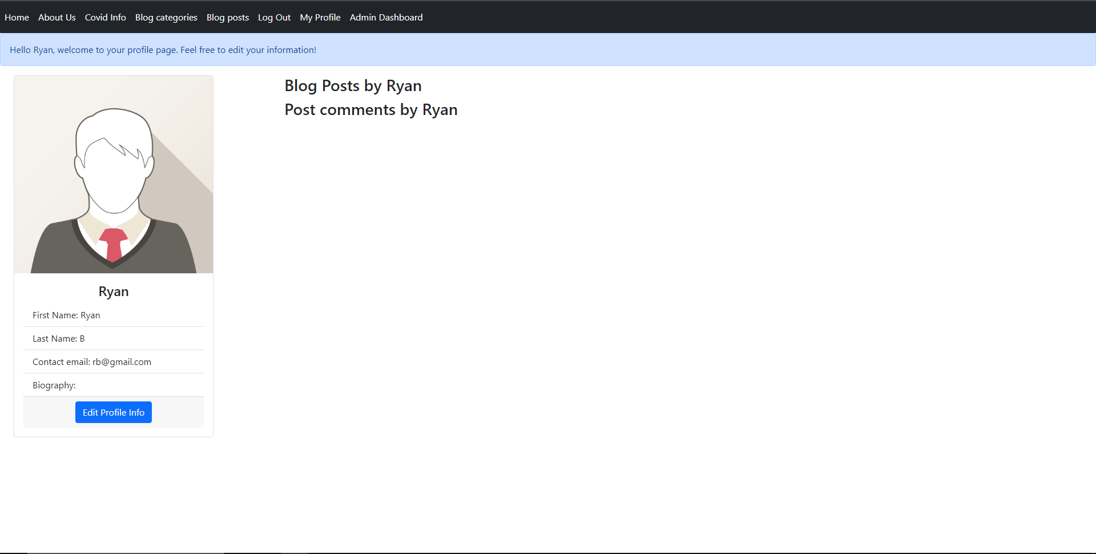

Covid Info Page

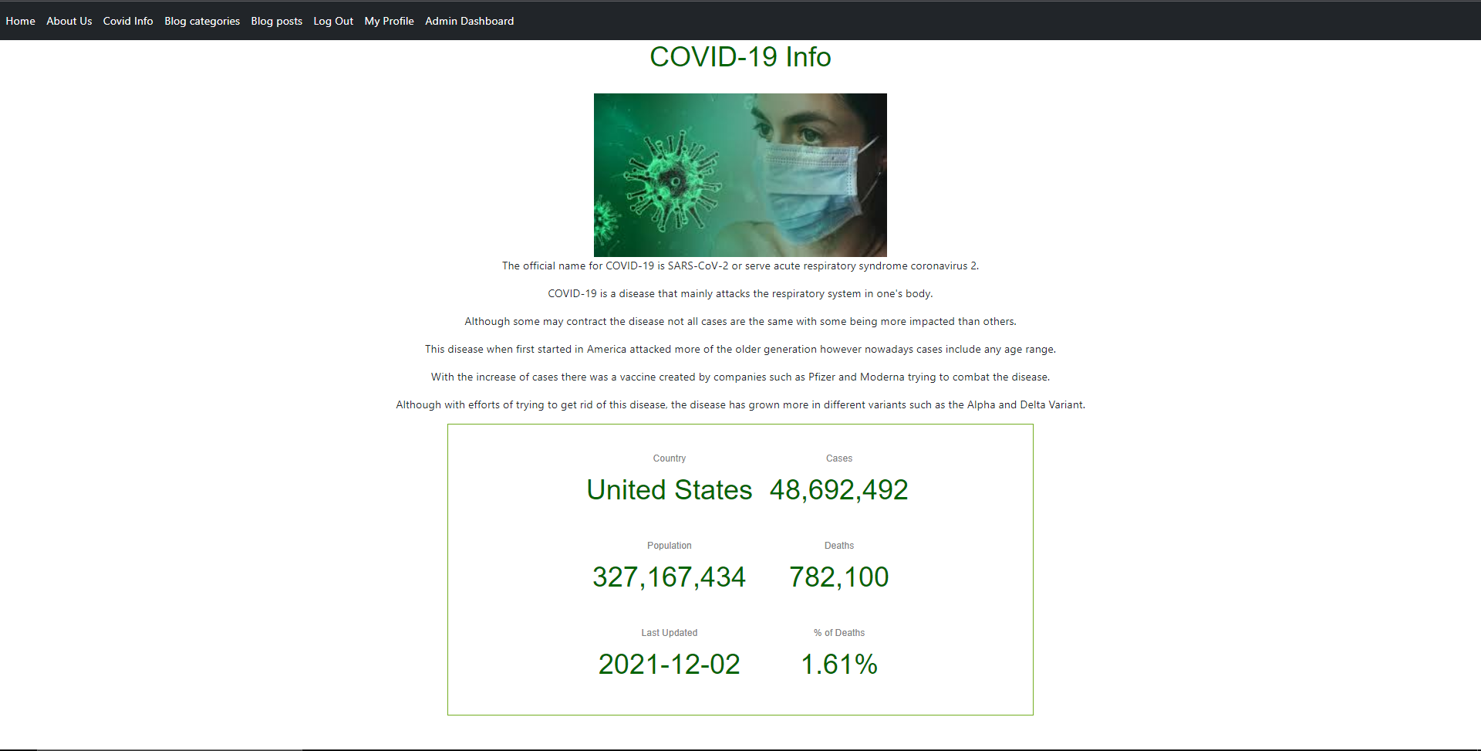

Website Browsing (Can click on all possible links)

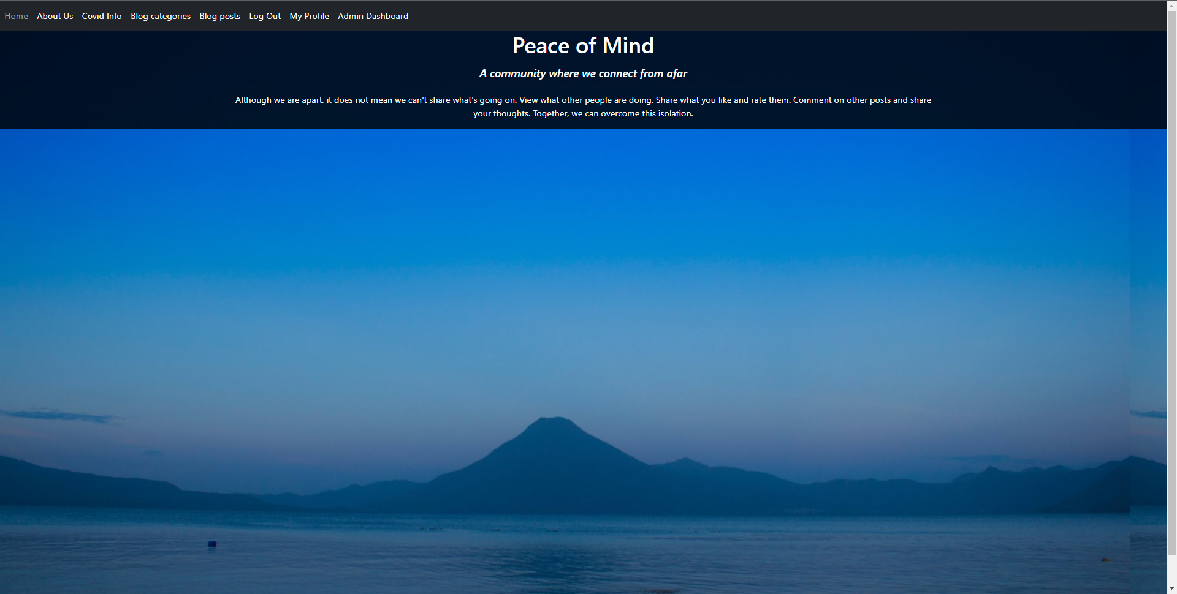

Comments

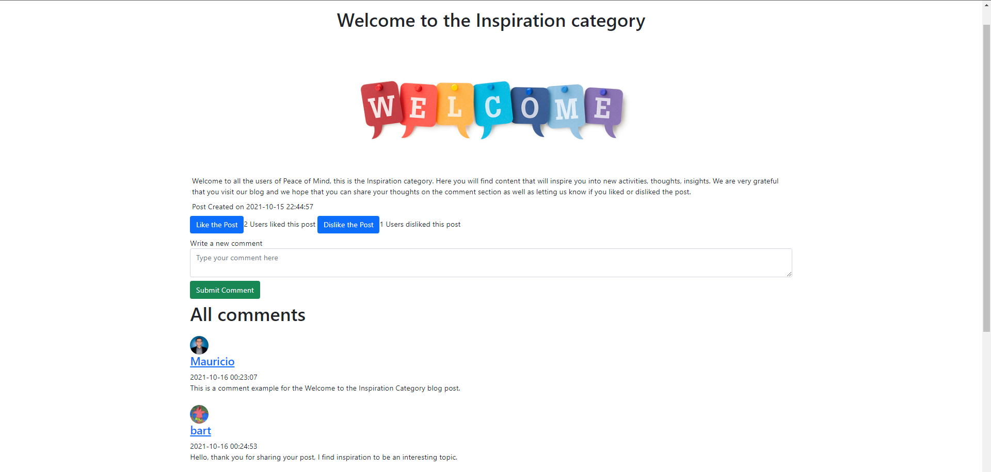

Blog Page

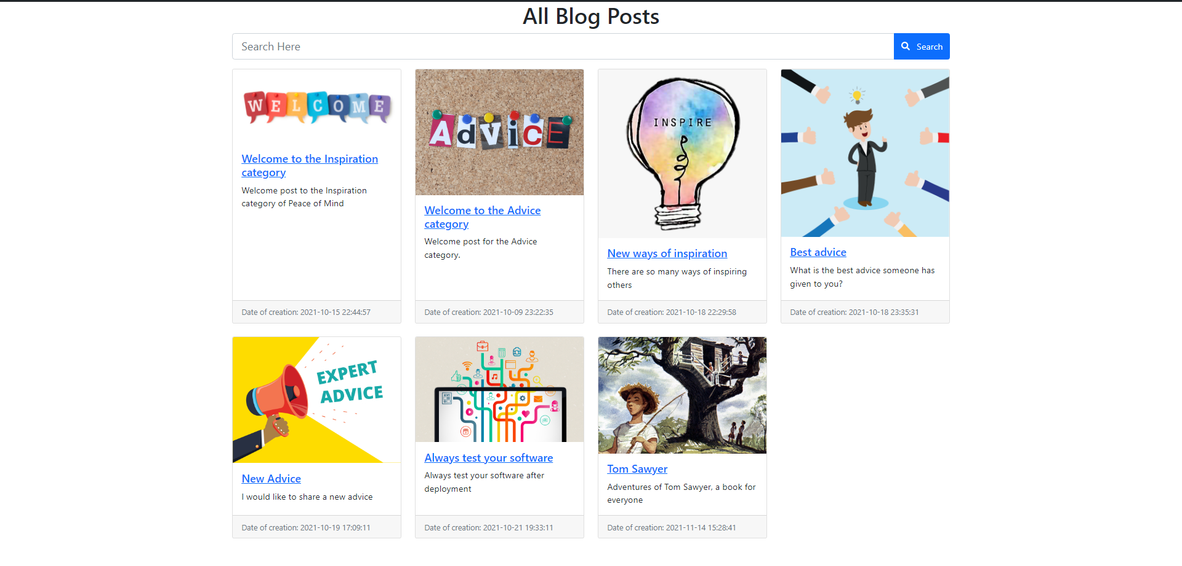

Administrative Rights

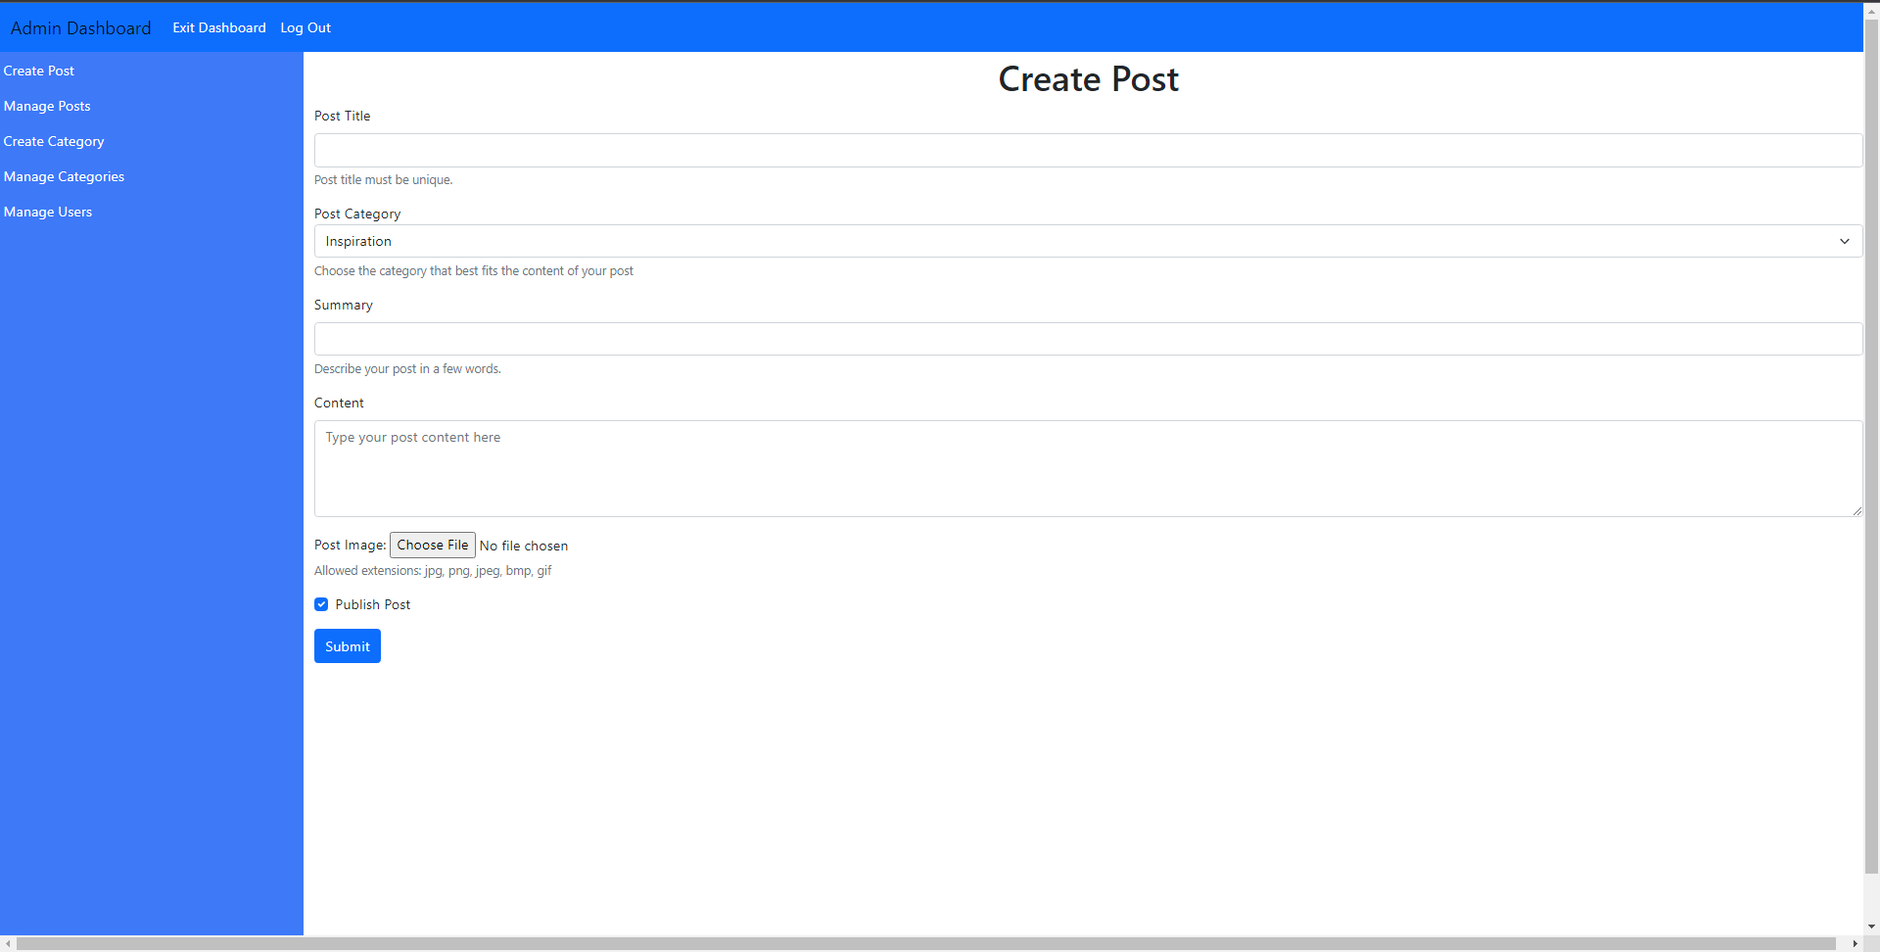

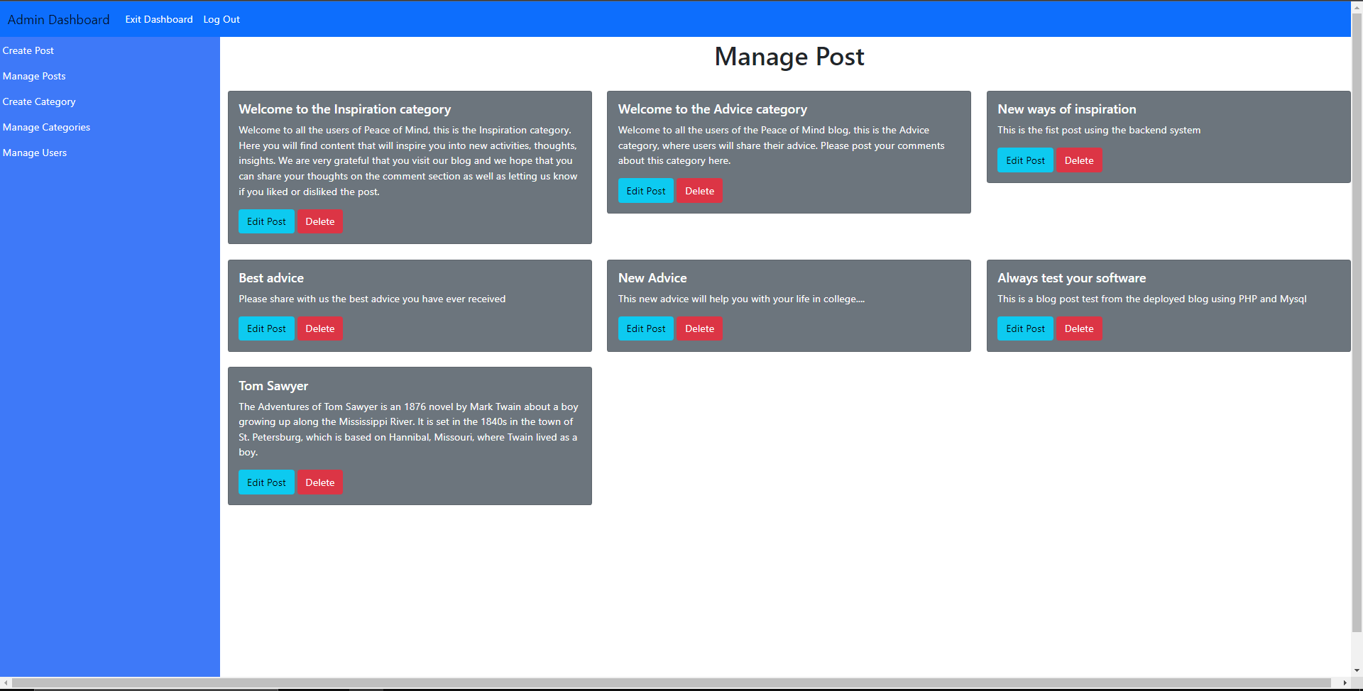

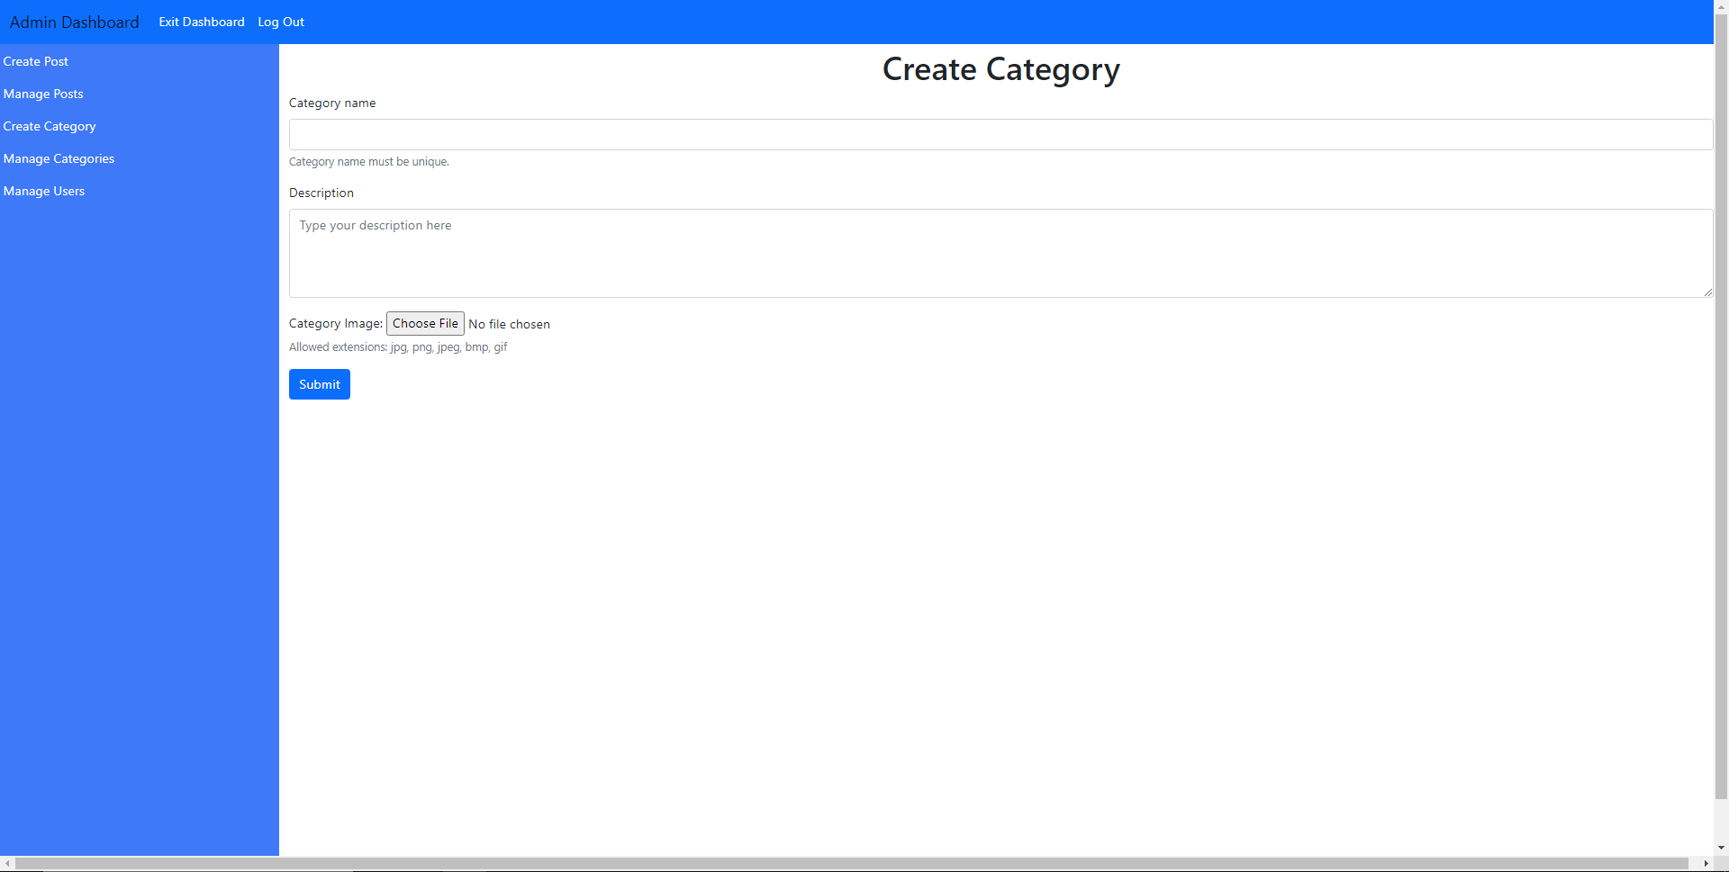

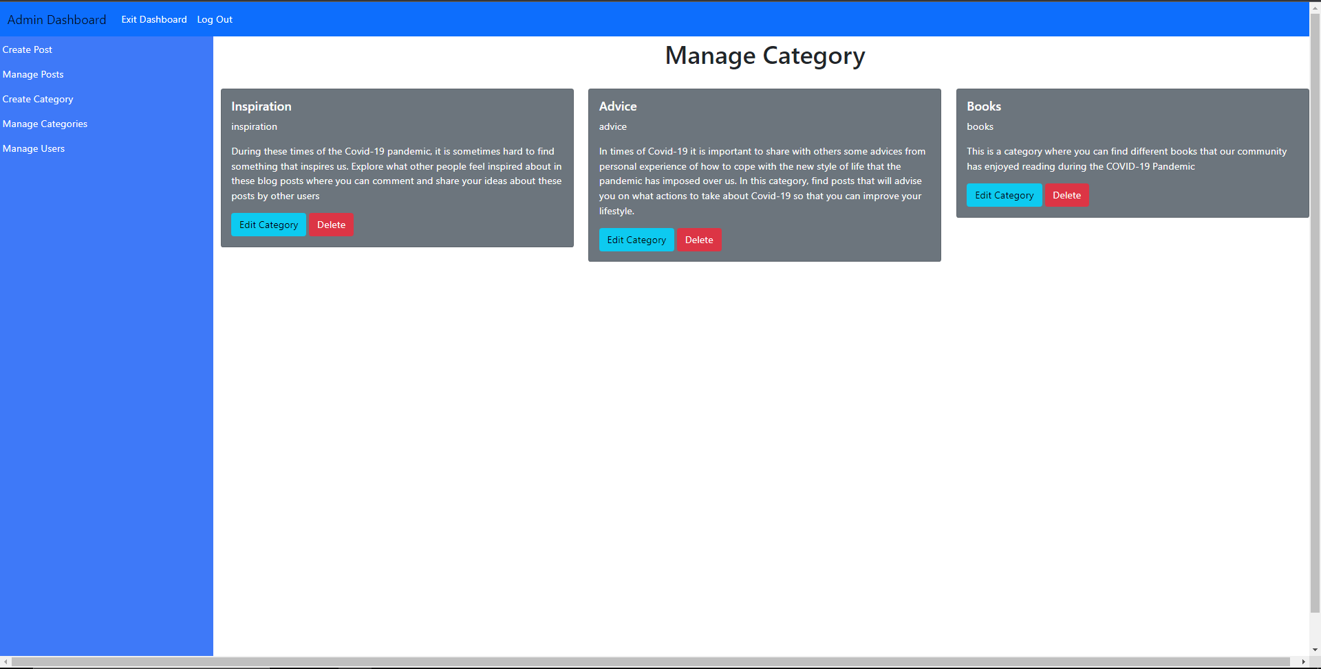

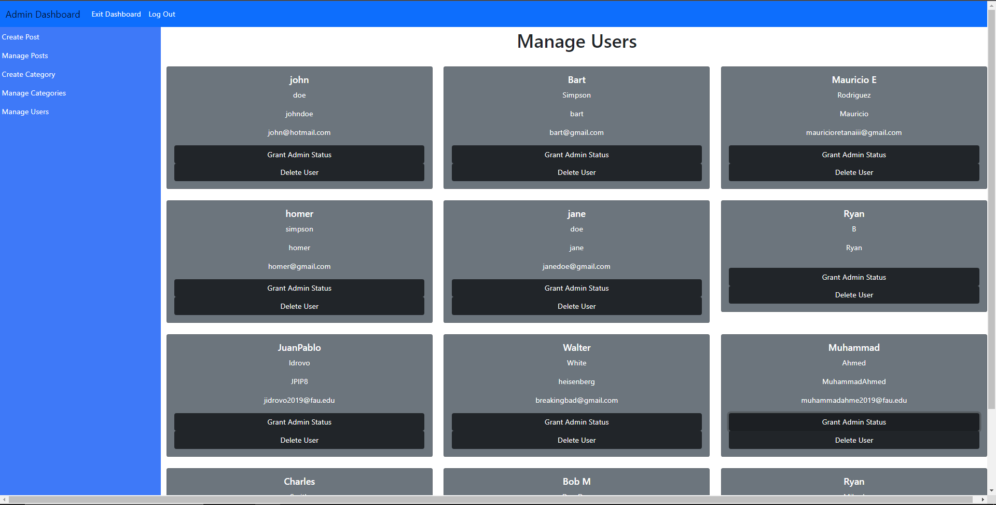

Category Page

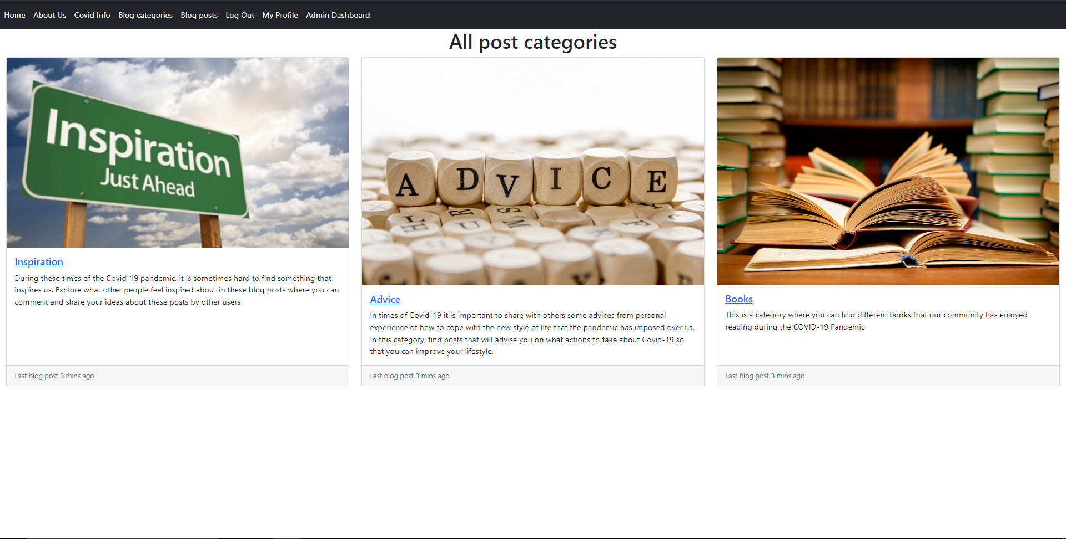

Like/Dislike Post

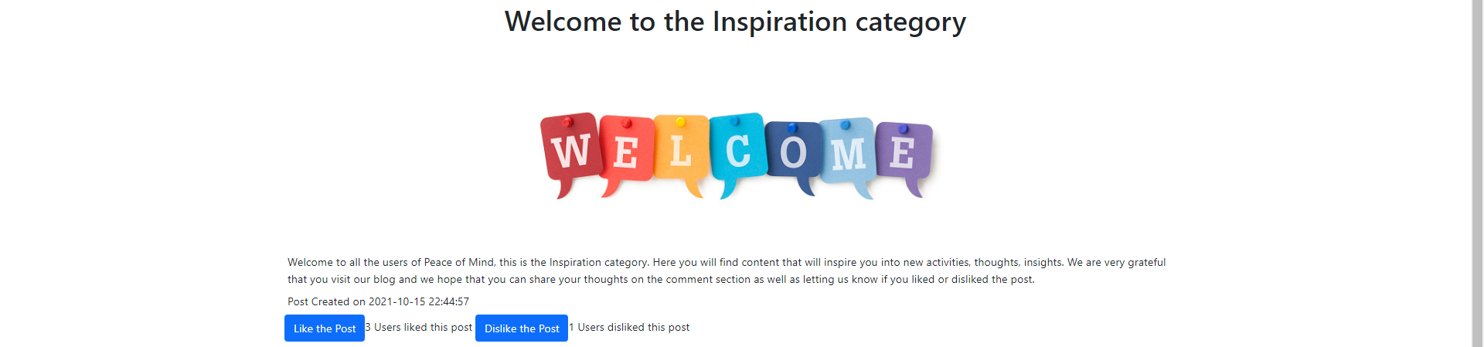

# 4 Google Analytics plot for your website

* Real time data for the last 30 minutes on December 6, 2021 at 2:50 p.m.

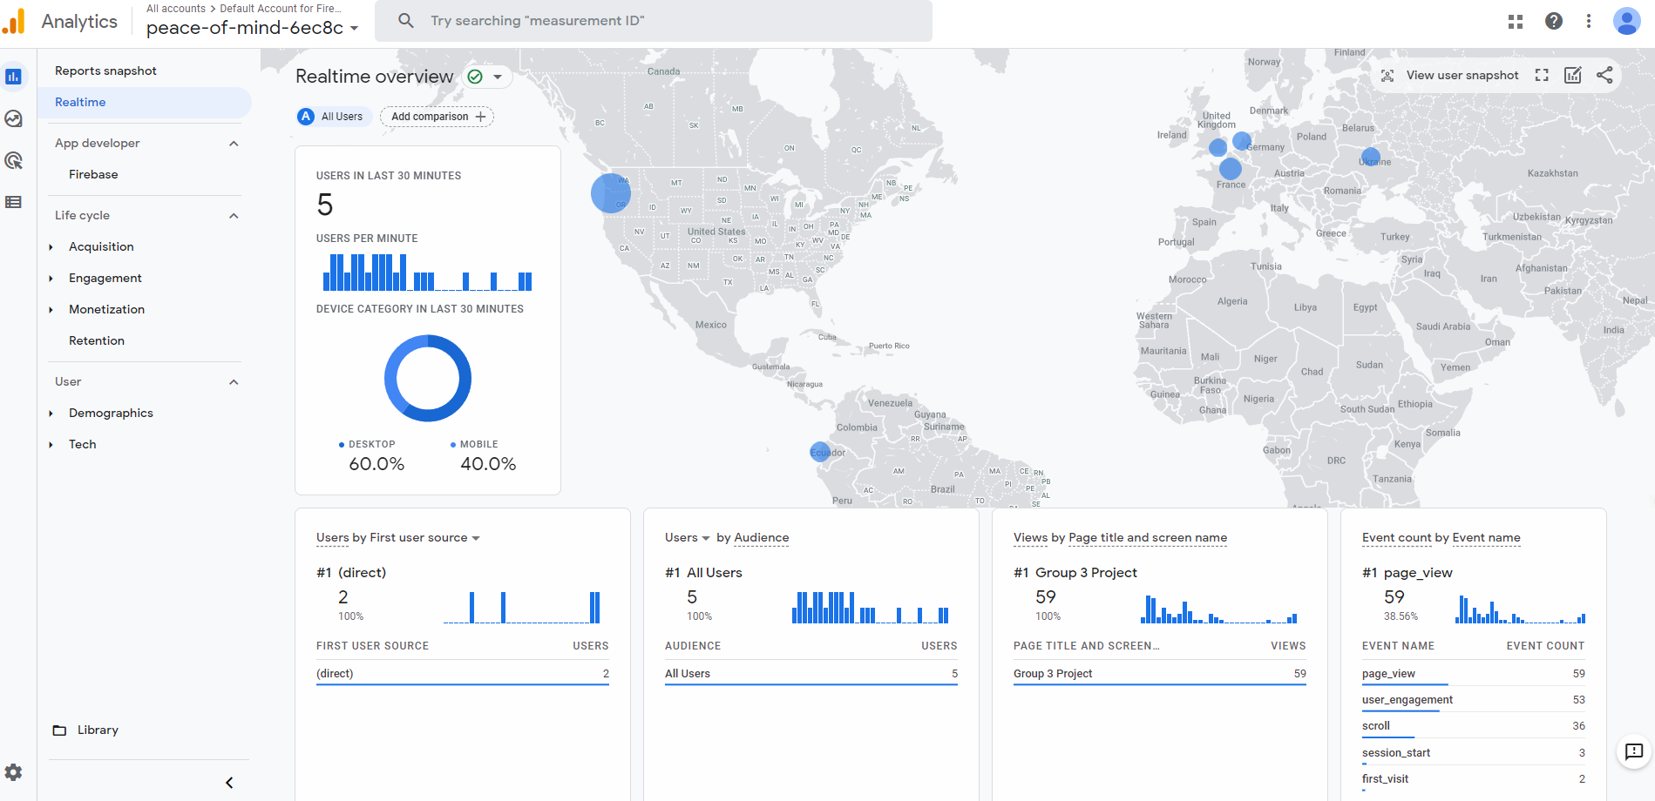

* Data snapshot from November 30 to December 6 (1 week)

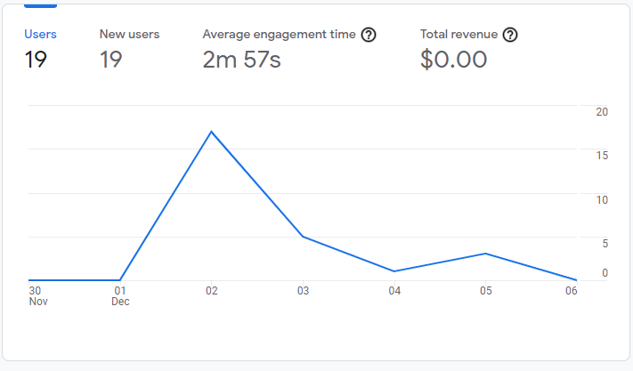

* Number of users by country

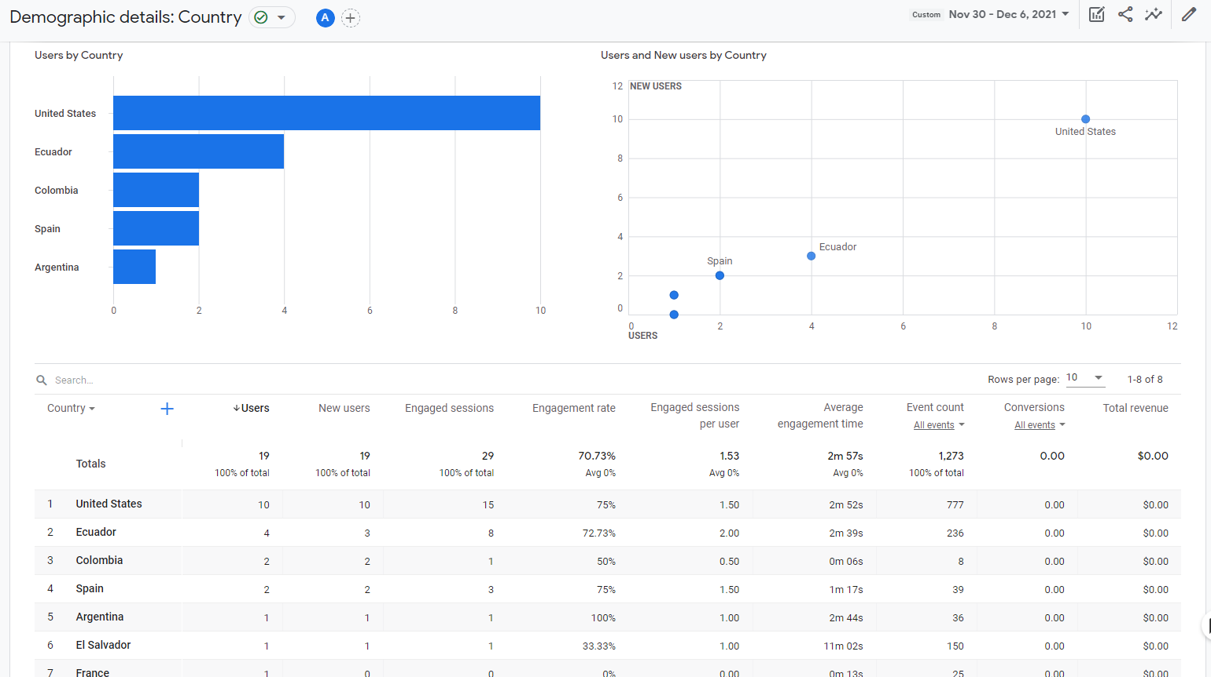

* User activity by time frame

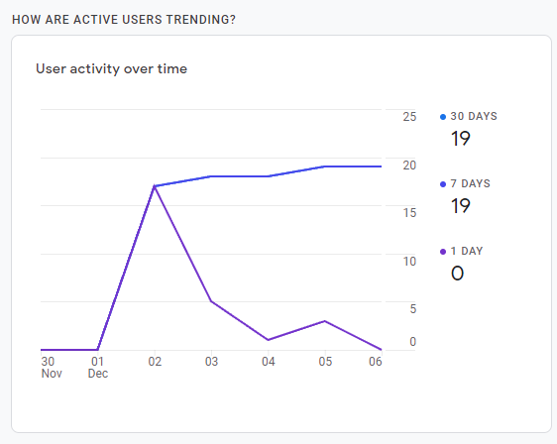

* Top events by users in numbers

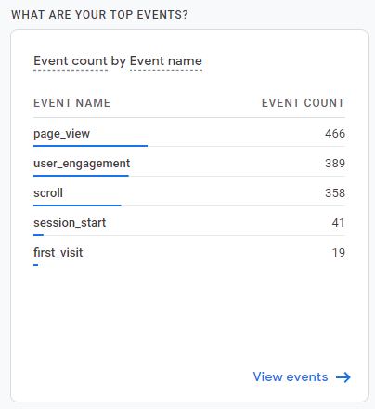

# 5 Team Member Contributions

Some of the feature implementations involved pair programming between members of our group, so these analytics do not reflect 100% accurately the contributions by each member.

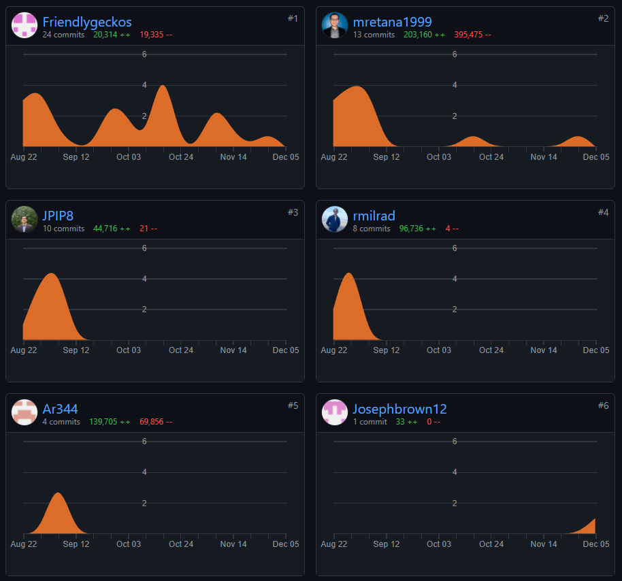

Number of contributions to the main branch timeline from GitHub:

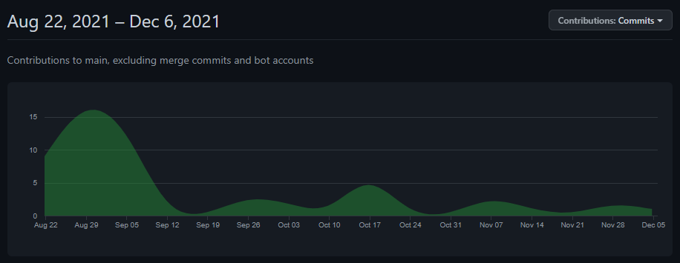

**Points Distribution:**

Ryan Bharath - 100/100

Joseph Brown - 100/100

Juan Pablo Idrovo - 100/100

Ryan Milrad - 100/100

Mauricio Retana Rodriguez - 100/100

# 6 Post Project Analysis

1. Main Challenges during the Project development:

Developing the project for this course involved many challenges that all the team members have gone through. These challenges included learning how to utilize version control software such as GitHub, learning how to make use of planning Agile development planning tools like Jira, learning new programming languages, libraries, frameworks, and platforms in order to develop and deploy the web application.

Although most of our group’s team members were somewhat familiar with GitHub since most of us had used to store and display our “portfolio” of projects in the web; not everybody had prior experience on using GitHub as a tool to develop group in a team. This became a challenge since it involves more coordination so as to not cause conflicts within the repository. These challenges with GitHub became more clear as the semester and our project advanced.

Since most of our team members did not have experience in working in team software projects, most of us were unfamiliar with Jira and the agile software development techniques and the logistics that it involves. Luckily, one of our team members took charge of managing the Jira dashboard and created and submitted all the tasks that we planned as a group.

Perhaps the most challenging problems that we had involved learning the programming languages that were used to develop the project. For example, our project is mostly based in PhP, a language that specializes in managing the backend side of a web application. It was a challenge to learn all the necessary functions and syntax that are used to design and implement the user interaction with the website and how to handle the input by the user and implement actions that use that input. More specifically, our team had to learn how to make operations on the database using the MySQLi PHP library.

Finally, we also had difficulties with the compatibility of some functions that are included in the MySQLi library that need some dependencies to be installed in the server that hosts the application. For example, our project used prepared statements which ensure that the user does not introduce SQL injections in the system and potentially erase part of the entire database. So, in order to use these functions we needed to install an extension called MySql_nd which was not available in the FAU lamp server platform. In order to overcome this challenge, our team had to look for an external hosting platform that would be compatible with PHP and that allowed us to have more freedom to install new dependencies.

1. What would you do better next time to address those challenges?

In order to do better next time, our team will continue learning more about version control software as well as team project planning software. In the case of the platform problems, next time we will take more time into researching which functionality of the programming languages being used will be compatible with the platform that we are using.

1. Features you have finished and those you’d like to finish but couldn’t be able to, and the reasons.

Features finished:

Our team was able to deliver a completely functional blog that can be maintained through the use interface without the need of interacting directly with the code and/or the database. We were able to develop all the necessary functionalities to have a working blog with a hierarchy of authors (administrators) and regular users, where important actions such as posting new content and managing the user hierarchy is reserved to administrators, while also maintaining a website where all users can interact with each other.

The following is a list of all the major functionality that our team was able to implement:

1. Account Creation
   1. The user can create an account to be a member of the website so that they can take advantage of the features that the website has.
2. About Us Page
   1. The user can navigate to this page to view the members who created the website.
3. Edit Profile
   1. The user can edit their profile where they can change their profile picture, name, contact information and biography.
4. Profile Page
   1. The user can now see their own and other peoples’ post and comments on Peace of Mind by going into their profile page. The user is also able to access those posts by clicking on the URL link.
5. Covid Info Page
   1. The user can access the covid information page where they can read up on information about Covid-19. They are also able to view the amount of cases and deaths so far.
6. Website Browsing
   1. The user can navigate to several pages on the website (About Us. Covid Information, Blog categories, Blog Post, Edit Profile pages).
7. Comments
   1. The user can view the blog post and make a comment on it.The comment is viewable by other users.
8. Blog Page
   1. The user can navigate through the blog page where they can see what blogs has been posted and what blogs they can view.
9. Administrative Rights
   1. The administrator is allowed to create new blog categories and new blog posts. They can also grant other users administrative rights.
   2. The administrator can create new blog categories to keep blog posts more organized
   3. The administrator can edit blog posts and edit blog categories
   4. The administrator can delete the user’s account upon request
10. Maintenance of the Website
    1. The owner of the website will be in charge of maintaining the webpage.
11. Category Page
    1. The user can view the category page and look at what they want to view. For example, if the user is interested in sports, they can take a look at the sports category
12. Like/Dislike Post
    1. Registered users can click the like or dislike button, and the number of persons that liked or disliked the same post will be displayed.

Unfinished features:

1. Implementing a books/movies/videogames category that would provide users access to those resources
   1. Reason: We were unable to implement this functionality since it would require a major redesign of the current database architecture, and we would also need to collect books/movies/videogames that are copyright free or that are available with adds
2. Implementing a live chat room
   1. Reason: We were not able to implement a chat room for our users due to time constraints.
3. Adding more sources of information to the Covid-19 information section, using APIs such as the Google Maps API
   1. Reason: Our team was unable to implement this due to time constraints and other courses’ projects due dates.
4. Knowledge gained and lessons learnt from your project and teamwork

During the development of this project we learned many lessons and knowledge about working in teams and how to properly organize a team in an effective manner by applying the Agile methodology where each week we assigned tasks to every team member. We also gained knowledge of how to work in teams with version control software such as GitHub. Finally, we also gained more knowledge on programming languages such as PhP and JavaScript, and we were able to put into practice our knowledge of relational databases to implement a blog system and deliver a complete web application.

# 7 Submission

7.1 Project Demo YouTube link (we also included a demo in the project presentation, however, because of time constraints it is shorter than the Milestone4 presentation):

[Milestone 4, Group 3 - Beta Launch Demonstration.](https://youtu.be/JwIZyYuxxgA)

7.2 Project Presentation YouTube link:

[Project Presentation](https://www.youtube.com/watch?v=RMokcpIOHN0)

# 7 GitHub Link

8.1 Group 3’s Repository Link: <https://github.com/CEN4010-F2021-g3/cen4010-group3>